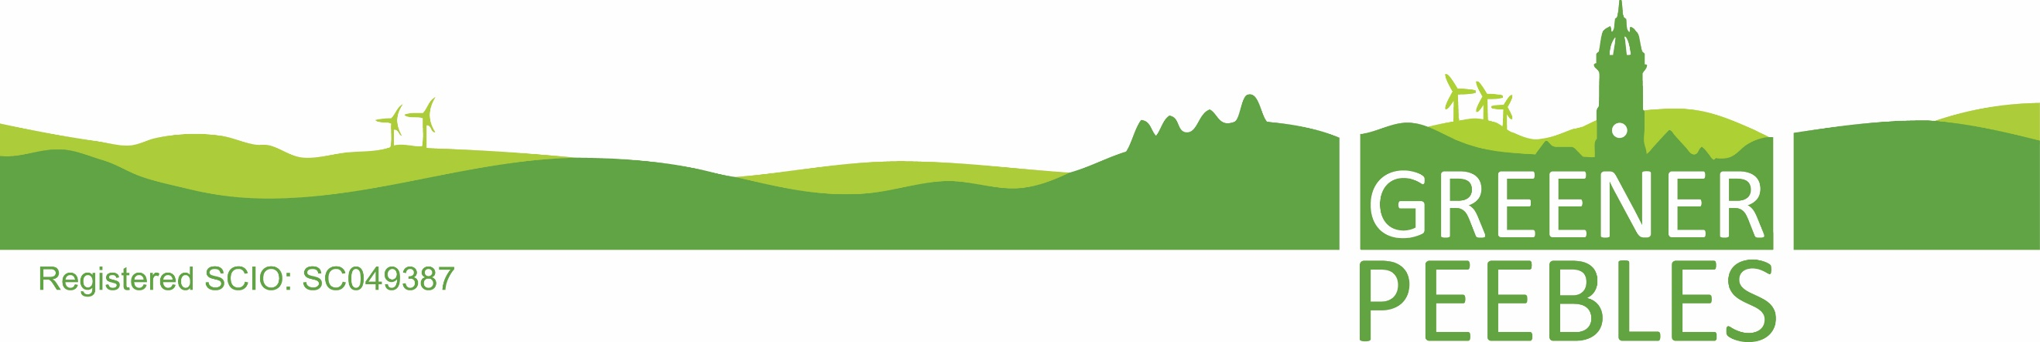

Membership to Greener Peebles

Membership to Greener Peebles is open to anyone who supports our objects which are:

To promote the advancement of community development, especially young people and those who are isolated or vulnerable, in the advancement of learning, particularly relating to activities which safeguard the health of the planet, and enhance the sustainability of the local environment of Peeblesshire promoting the advancement of environmental protection

Application
- Any person who wishes to become a member must sign this written application for membership; the application will then be considered by the board at its next board meeting.
- The board may, at its discretion, refuse to admit any person to membership.
- The board must notify each applicant promptly (in writing or by e-mail) of its decision on whether to admit them to membership.
Membership subscription
- No membership subscription will be payable.
Withdrawal from membership
- Any person who wants to withdraw from membership must give a written notice of withdrawal to the organisation, signed by them; they will cease to be a member as from the time when the notice is received by the organisation.
Transfer of membership
- Membership of the organisation may not be transferred by a member.

Meetings
- The board must arrange a meeting of members attending in person or virtually (an annual general meeting or "AGM") in each calendar year.
Voting at members’ meetings
- Every member has one vote. A person entitled to vote upon the business at a meeting may do so either in person or virtually where arrangements for virtual attendance have been made.

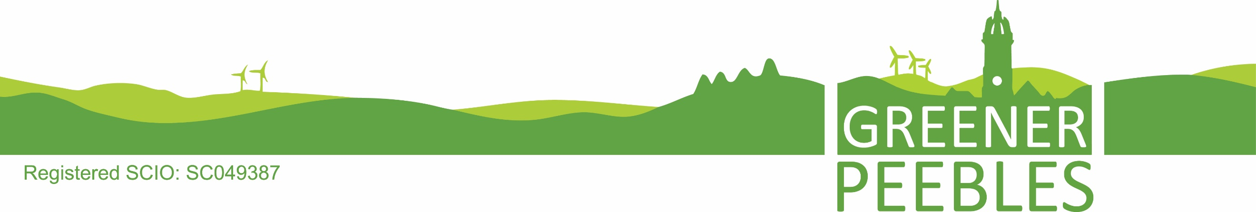

Become a member today

Date

Name

Address

Email

Telephone Number

Date of Birth

I aim to, or I currently support the aims of Greener Peebles and would like to become a member of the organisation. I live, work or operate (e.g. study or volunteer) in the Peebles area.

Yes

No

I agree to Greener Peebles contacting me occasionally to help inform me of their work in the community. I understand I have a vote at the annual general meeting to steer the work of the organisation. Details will be stored securely and will not be shared with any third party (details of the privacy policy can be found on the Greener Peebles website or on request.)

Yes

No

Signature

